A PRELIMINARY REPORT ON

IMAGE-BASED ANIMAL TYPE CLASSIFICATION FOR CATTLE AND BUFFALOES
SUBMITTED TO THE SAVITRIBAI PHULE PUNE UNIVERSITY, PUNE IN THE PARTIAL FULFILLMENT OF THE REQUIREMENTS
FOR THE AWARD OF THE DEGREE OF

BACHELOR OF ENGINEERING (COMPUTER ENGINEERING)

SUBMITTED BY

MR. AVADHUT PATIL
MR. DNYANESHWAR TUPE
MR. AVINASH MARKAD

Under the Guidance of DR. NILESH MALI



DEPARTMENT OF COMPUTER ENGINEERING AJEENKYA DY PATIL SCHOOL OF ENGINEERING
CHARHOLI BUDRUK, LOHEGAON, PUNE 412105
SAVITRIBAI PHULE PUNE UNIVERSITY 2025 -2026



AJEENKYA DY PATIL SCHOOL OF ENGINEERING DEPARTMENT OF COMPUTER ENGINEERING
CERTIFICATE

This is to certify that the Project Report Entitled
IMAGE-BASED ANIMAL TYPE CLASSIFICATION FOR CATTLE AND BUFFALOES
Submitted by
MR. AVADHUT PATIL 72332704B
MR. DNYANESHWAR TUPE 72332714K
MR. AVINASH MARKAD 72332693C

is a bonafide student of this institute and the work has been carried out by him/her under the supervision of Dr. Nilesh Mali and it is approved for the partial fulfillment of the requirement of Savitribai Phule Pune University, for the award of the degree of Bachelor of Engineering (Computer Engineering).

Dr. Nilesh Mali Dr. Nilesh Mali
Guide H.O.D
Department of Computer Engineering Department of Computer Engineering

Signature of Internal Examiner: Signature of External Examiner:

Dr. F. B. Sayyad
Principal
AJEENKYA DY PATIL SCHOOL OF ENGINEERING, Lohegaon, Pune-412015

Place: Pune Date: / /2025

ACKNOWLEDGEMENT

It gives us immense pleasure to present the preliminary project report on “Image-based Animal Type Classification for Cattle and Buffaloes” We would like to express our heartfelt gratitude to our Internal Guide, Dr. Nilesh Mali, for his continuous guidance, valuable suggestions, and constant encouragement throughout the completion of this project. His support and insights have been invaluable to our work.
We are also sincerely thankful to Dr. Nilesh Mali, Head of the Department of Computer Engineering and Project Coordinator, ADYPSOE, Lohegaon, Pune, for his motivation, timely assistance, and for providing us with all the necessary facilities to carry out this project successfully.
Our deep sense of appreciation also goes to our Principal, Dr. F. B. Sayyad, for his constant encouragement and for creating a conducive learning environment that inspired us to give our best efforts.
We would also like to thank all the faculty members and technical staff of our department for their valuable cooperation and support during the course of this project.
Finally, we extend our sincere thanks to everyone who directly or indirectly contributed to the successful completion of this project.

Mr. Avadhut Patil
Mr. Dnyaneshwar Tupe
Mr. Avinash Markad

ABSTRACT

This project focuses on the automated classification of animal types using digital images. With the growth of image data across the internet and camera-based monitoring systems, identifying animals manually becomes time-consuming and prone to human error. The problem addressed in this project is the need for a reliable and efficient method to classify animals accurately based solely on their visual characteristics. To solve this, machine learning and deep learning techniques, particularly Convolutional Neural Networks (CNNs), are utilized to learn distinguishing features such as shape, texture, and color patterns from a dataset of animal images. The system is trained and tested to achieve high accuracy in differentiating between multiple animal categories. This approach reduces manual effort, improves classification speed, and enhances consistency in recognition tasks. The conclusion of this project highlights that automated animal classification can significantly support fields like wildlife monitoring, veterinary research, and biodiversity management, offering a scalable and high-performance solution for real-world applications.

Keywords: Image classification, Animal recognition, Convolutional Neural Network, Deep learning, Machine learning, Pattern recognition

TABLE OF CONTENTS

- LIST OF ABBREVATIONS
- LIST OF FIGURES
- LIST OF TABLES

Sr. No. |  | Title of Chapter | Page No.
01 |  | Introduction | 1
 | 1.1 | Overview | 1
 | 1.2 | Motivation | 2
 | 1.3 | Literature Survey | 3
02 |  | Problem Definition & Scope | 10
 | 2.1 | Problem Definition | 10
 | 2.2 | Goal & Objective | 11
 | 2.3 | Statement of Scope | 12
 | 2.4 | Methodologies of Problem Solving and Efficiency issues | 13
03 |  | Project Plan | 16
 | 3.1 | Project Estimates | 16
 | 3.2 | Risk Management w.r.t NP-Hard Analysis | 19
 | 3.3 | Project Schedule | 20
04 |  | Software Requirements Specification | 21
 | 4.1 | Database Requirements | 21
 | 4.2 | Software Requirements (Platform Choice) | 21
 | 4.2 | Hardware Requirements | 22
 | 4.3 | Analysis Models: SDLC Model to be applied | 23
05 |  | System Design | 25
 | 5.1 | System Architecture | 25
 | 5.2 | Data Flow Diagrams | 28
 | 5.3 | Entity Relationship Diagram | 30

 | 5.3 | Use Case Diagram | 32
 | 5.4
 | 5.5
 | 5.6
 | 5.7
 | 5.8
 | 5.9
 | 5.10
06 |  | Other Specification | 46
 | 6.1 | Advantages | 46
 | 6.2 | Limitations | 47
 | 6.3 | Applications | 48
07 |  | Conclusions & Future Work | 49
 |  | Appendix A: Problem statement feasibility assessment using, satisfiability analysis and NP Hard, NP-Complete or P type using modern algebra and relevant mathematical models.  Appendix B: Details of the papers referred in IEEE format (given earlier) Summary of the above paper in not more than 3-4 lines. Here you should write the seed idea of the papers you had referred for preparation of this project report in the following format.  Example:  Thomas Noltey, Hans Hanssony, Lucia Lo Belloz,”Communication Buses for Automotive Applications” In Proceedings of the 3rd Information Survivability Workshop (ISW-2007), Boston, Massachusetts, USA, October 2007. IEEE Computer Society.  Appendix C: Plagiarism Report | 51
 |  | References | 54

- LIST OF ABBREVIATIONS

Abbreviation | Full Form
AI | Artificial Intelligence
ML | Machine Learning
DL | Deep Learning
API | Application Programming Interface
CV | Computer Vision
CNN | Convolutional Neural Network
SQL | Structured Query Language
HTML | Hyper Text Markup Language
CSS | Cascading Style Sheets
PDF | Portable Document Format
CSV | Comma-Separated Values
F1-Score | 2 × (Precision × Recall) / (Precision + Recall)
DFD | Data Flow Diagram
SDLC | Software Development Life Cycle
DB | Database
UI | User Interface
TP | True Positive
TN | True Negative
FP | False Positive
FN | False Negative

- LIST OF FIGURES

FIGURE | ILLUSTRATION | PAGE NO.
5.1 | System Architecture | 32
5.2 | System Workflow | 37
5.3 | Data Flow Diagram | 42
5.4 | Entity Relationship Diagram | 44

- LIST OF TABLES

TABLE | ILLUSTRATION | PAGE NO.
1.1 | Summary of Empirical Findings from Previous Study | 13
1.2 | Summary of Key Findings from Previous Studies | 14
1.3 | Research Gaps Identified from Literature Review | 15
3.1 | Key Phases & Duration | 23
3.2 | Identified Risks and Mitigation Strategies | 26
3.3 | Project Schedule in Gantt Chart | 27

- INTRODUCTION

OVERVIEW
In recent years, the rapid growth of digital imaging technologies and the availability of large-scale image datasets have encouraged the development of automated image classification systems. Animal classification based on images is an important area of research, as it supports various applications such as wildlife conservation, veterinary diagnosis, intelligent surveillance, and educational tools. Traditionally, identifying animal species has relied on manual observation and expert knowledge, which can be slow, inconsistent, and limited by human capability. With advancements in Artificial Intelligence, particularly in Machine Learning and Deep Learning, automated systems can now analyze visual features from images with high accuracy.
This project aims to classify animals into their respective categories by processing and learning from input images. Convolutional Neural Networks (CNNs), which are known for their strong performance in computer vision tasks, are employed to automatically extract and recognize patterns, shapes, colors, and textures that distinguish different animal types. The model is trained using a labeled dataset of animal images and evaluated based on its performance metrics such as accuracy and precision. By providing a systematic and efficient approach to animal classification, this project demonstrates the potential of modern AI techniques in reducing manual effort and enhancing the speed and reliability of recognition tasks. The resulting system can be adapted or expanded for use in ecological monitoring, automated tagging of animal imagery, and smart wildlife management systems.
Furthermore, the integration of automated animal recognition systems can help address key challenges faced in various real-world environments. For instance, in wildlife reserves and forests, continuous human monitoring is difficult due to geographical and safety constraints. By deploying camera traps or surveillance devices paired with image-based classification models, animal populations can be observed and analyzed without disturbing their natural habitats. In educational and research settings, such a system enables students and researchers to identify species instantly, reducing dependency on expert taxonomists. Overall, the proposed image-based animal classification system not only enhances operational efficiency but also contributes to improving the accuracy and scalability of animal identification across multiple domains.

MOTIVATION
The motivation behind this project arises from the growing need for efficient and accurate animal identification methods in various fields such as wildlife conservation, biological research, and smart surveillance systems. Manual identification of animals from images requires expert knowledge and can be highly time-consuming, especially when dealing with large volumes of data collected from camera traps, zoos, or research laboratories. Additionally, the rapid expansion of image-sharing platforms and monitoring technologies has resulted in massive datasets that are difficult to analyze without automation. There is a strong need for a system that can quickly and reliably classify animals based on visual characteristics without human intervention.
Advancements in Artificial Intelligence, especially in Deep Learning and Convolutional Neural Networks (CNNs), have provided powerful tools for recognizing complex patterns in images. These technologies offer the potential to reduce the workload on researchers, improve decision-making accuracy, and support real-time applications such as wildlife monitoring and animal behavior analysis. By developing an automated animal classification system, this project aims to contribute to the creation of smarter and more scalable solutions that enhance efficiency, reduce errors, and promote technological support in areas that rely heavily on visual identification of animals.
Moreover, this project is motivated by the desire to bridge the gap between modern technology and environmental awareness. As biodiversity continues to decline due to climate change, habitat loss, and human activities, having accurate data on animal presence and distribution is crucial for conservation efforts. Automated image-based classification can assist researchers and environmental organizations in tracking species diversity, studying animal migration patterns, and detecting endangered species more effectively. By providing a fast and scalable solution for animal identification, the system encourages the use of AI in environmental conservation, helping to preserve wildlife and maintain ecological balance for future generations.

LITERATURE SURVEY

Introduction
Accurate identification of livestock is an essential aspect of modern dairy and farm management. Traditionally, farmers and veterinarians identify cattle and buffaloes through manual visual inspection based on features such as horn shape, facial structure, ear pattern, and body size. However, this manual approach is highly subjective, error-prone, and time-consuming—especially when dealing with large herds or mixed livestock groups. Misclassification may lead to incorrect feed distribution, improper veterinary treatment, and errors in livestock record management.
With advancements in Computer Vision and Deep Learning, researchers have shifted towards developing automated animal classification systems using image datasets. Convolutional Neural Networks (CNNs) have proven effective in extracting deep visual features for classification tasks. However, distinguishing between cattle and buffaloes remains a challenge due to their high anatomical similarity, variations in image backgrounds, and inconsistent lighting conditions in real-world farm environments.
The current project builds upon previous research by developing a deep learning-based image classification model specifically trained to differentiate cattle from buffaloes. The system aims to provide a fast, accurate, and non-invasive solution that can support livestock monitoring, dairy farm automation, and veterinary decision-making.

Employability Concepts and Frameworks

Image-based animal classification is a subset of computer vision and pattern recognition, focusing on the extraction and interpretation of meaningful visual features. The classification process typically involves sequential feature learning, moving from low-level pixel patterns to high-level semantic understanding.
Key frameworks and concepts in this domain include:
- Low-Level Feature Analysis: Detects basic visual elements such as edges,
textures, and color gradients.
- Mid-Level Feature Recognition: Identifies distinct animal characteristics such as
ear positioning, face structure, horn curvature, and body contours.
- High-Level Semantic Classification: Maps extracted features to specific animal
categories (e.g., cattle or buffalo).
Studies such as Norouzzadeh et al. (2018) demonstrated that deep learning models can classify wildlife species with near-human accuracy when trained on large labeled datasets. Similarly, Khosla et al. (2015) highlighted the importance of transfer learning in achieving high performance even with smaller datasets. These frameworks emphasize that deep hierarchical feature learning is crucial for fine-grained classification tasks involving visually similar species.

Relevance of Classification Theory in Image Recognition

Classification Theory in computer vision focuses on how well a system can learn, differentiate, and categorize visual patterns based on extracted features. It establishes the relationship between input data (images) and predefined output categories (animal types) using structured learning algorithms. In this context, Convolutional Neural Networks (CNNs) play a key role due to their ability to automatically detect patterns such as shape, texture, and color distribution.
The theory includes several levels of visual feature interpretation:
- P–P Fit (Pattern-to-Pattern Recognition): Coat texture, face shape, horn structure, ear
size, body contour patterns.
- P–V Fit (Photographic-to-Visual Environment Fit): Lighting conditions, background
complexity, distance from camera, camera angle.
- P–J Fit (Pixel-to-Feature Extraction Fit): Feature extraction accuracy, model learning
depth, classification differentiation between cattle vs buffalo.
When applied to image-based animal classification, Classification Theory helps ensure the model accurately learns distinguishing characteristics between animal types, reducing ambiguity and misclassification. This theoretical foundation is essential for developing a system that consistently performs accurate and automated classification, supporting real-world applications like wildlife monitoring, veterinary diagnostics, and smart image retrieval systems.

Empirical Studies on Animal Image Classification

Several empirical studies conducted globally highlight significant advancements and challenges in automated animal image classification. Researchers have extensively used deep learning models—particularly Convolutional Neural Networks (CNNs)—to improve classification accuracy across diverse animal datasets. For instance, Norouzzadeh et al. (2018) conducted a large-scale study using the “Snapshot Serengeti” dataset to automatically classify wildlife species captured by camera traps. Their research demonstrated that deep learning models could approach human-level performance when provided with sufficient training data and well-labeled images. Similarly, Khosla et al. (2015) applied feature extraction and transfer learning techniques to classify animal species and reported enhanced accuracy and reduced training time.
The key findings of their study are summarized below.
Table 1.1: Summary of Empirical Findings from Previous Studies on Animal Image Classification

Study Focus Category | Image / Feature Aspects Assessed | Findings (Model Performance & Limitations) | Interpretation / Remarks
Low-Level Feature Extraction | Coat texture, face shape, horn structure, ear size, body contour patterns | Models performed better when animals had distinct visible features; accuracy dropped when images had mud, shadows, or partial visibility | Indicates need for clear image datasets and preprocessing to enhance pattern visibility
Mid-Level Feature Recognition | Lighting conditions, background complexity, distance from camera, camera angle | Images captured in uneven lighting or cluttered backgrounds caused recognition difficulty; performance improved in stable and natural lighting | Suggests importance of controlled image capture or background removal for reliable classification
High-Level Semantic Classification | Feature extraction accuracy, model learning depth, classification differentiation between cattle vs buffalo | Significant classification errors occurred when animals had similar coat color or body size; advanced CNN models improved separation accuracy | Highlights need for deeper learning models and larger labeled datasets for high precision
Overall Observation | — | Average accuracy across studies ranged from ~70% to 90%, depending on dataset quality and model architecture | Confirms that dataset diversity and training methodology strongly influence final classification accuracy

    - Summary of Key Findings from Previous Studies
Table 1.2: Summary of Key Findings from Previous Studies

Sr.  No. | Key Findings | Source / Author
1 |  | Finch et al. (2013), Andrews & Higson (2008)
2 |  | Kristof-Brown et al. (2005), Holland (1997)
3 |  | Metilda & Neena (2016)
4 | Most employability studies rely on manual surveys and static data sources. | Harvey (2001), Yorke  (2006)
5 | There is a strong need for data-driven, technology- based employability assessment. | OECD Skills Report (2019), CBI & NUS (2011)

    - Research Gaps Identified
Despite extensive literature on employability, several critical gaps remain unaddressed.

Table 1.3: Research Gaps Identified from Literature Review

Sr.  No. | Research Gap | Explanation from Literature | How Current Project Addresses It
1 | Limited automation in livestock identification | Many existing systems rely on manual observation or simple feature-based classification, leading to inconsistent accuracy. | Utilizes automated image classification using Convolutional Neural Networks (CNNs) to provide consistent and scalable recognition.
2 | Difficulty in distinguishing visually similar species (Cattle vs. Buffaloes) | Previous models show decreased accuracy when animals share similar color, size, or structural attributes. | Employs deep feature extraction and data augmentation to learn fine-grained differences in facial structure, horns, and body shape.
3 | Lack of real-time monitoring applications | Most studies focus on offline classification with static datasets and do not support real-time decision-making. | Integrates a pipeline that can be extended for real-time classification using camera input or video streams.
4 | Insufficient large and diverse training datasets | Performance declines when training data lacks variety in lighting, background, and animal posture. | Uses a diversified dataset and preprocessing techniques such as normalization, background reduction, and image augmentation for robust training.

    - Technological Advancements and Proposed Contribution
Recent advancements in Computer Vision, Deep Learning, and Pattern Recognition have significantly improved the accuracy and efficiency of automated animal identification systems. Convolutional Neural Networks (CNNs) have enabled models to learn visual features directly from images, eliminating the need for manual feature engineering. Additionally, techniques such as transfer learning, data augmentation, and fine-grained image classification have enhanced the ability to distinguish between visually similar species like cattle and buffaloes.
The proposed system innovates by integrating:
- Automated Image Preprocessing (noise reduction, resizing, normalization)
- Deep Feature Extraction using CNN-based architectures
- Species Classification Module to differentiate between cattle and buffaloes
- Model Optimization Techniques to improve accuracy and reduce computation cost
- Scalable Deployment Framework that can be extended for real-time camera-based monitoring
This integrated approach bridges the gap between traditional manual identification methods and modern automated livestock classification. It contributes towards building efficient, scalable, and practical solutions for smart dairy farming, animal record management, and livestock monitoring systems.

Summary of Literature Survey
From the reviewed literature, the following conclusions can be drawn:
- Automated image-based animal classification is feasible, but system accuracy
depends heavily on the quality and diversity of training datasets.
- Distinguishing closely related species (such as cattle and buffaloes) remains a
challenge due to similarities in physical characteristics.
- Existing studies demonstrate strong potential for deep learning-based
classification, yet practical real-time deployment in livestock environments is still limited.
- The adoption of advanced CNN architectures and robust preprocessing techniques
significantly improves classification performance and generalization capability.
The current project contributes by developing an AI-powered image classification model tailored specifically for cattle and buffalo identification. It enhances accuracy through optimized training workflows and provides a pathway for real-time implementation, supporting practical use in dairy farms, veterinary applications, and animal monitoring systems.

PROBLEM DEFINATION & SCOPE

PROBLEM DEFINITION
In livestock management, accurate identification of animal type is essential for maintaining proper health records, monitoring breed characteristics, regulating feeding patterns, and ensuring efficient farm operations. However, distinguishing between visually similar animals—especially cattle and buffaloes—is often done manually by farmers or veterinarians. This manual classification is subjective, time-consuming, and prone to errors, particularly when dealing with large herds, poor lighting conditions, or mixed grazing environments.
Traditional identification methods such as tagging, branding, or manual documentation are not only labor-intensive but may also cause discomfort or harm to the animals. Furthermore, these methods do not adapt well to automated livestock monitoring systems used in modern dairy farms.
With advancements in computer vision and deep learning, there is a growing opportunity to automate the process of animal type classification using images captured through cameras or mobile devices. However, existing systems either lack accuracy or fail to differentiate animals with similar visual features such as body size, coat color, and head shape, making them less reliable for real-world use.
To address these challenges, the proposed project develops an AI-based image classification system capable of accurately identifying whether an animal is cattle or buffalo by analyzing visual features such as face structure, horn shape, ear pattern, and body contours using Convolutional Neural Networks (CNNs). The system aims to provide fast, scalable, and non-invasive classification results that support smart livestock management, veterinary health monitoring, and farm automation.

GOAL AND OBJECTIVES

Goal:
The primary goal of this project is to develop an AI-based automated image classification system that accurately distinguishes between cattle and buffaloes using computer vision and deep learning techniques. The system aims to support livestock management by providing a fast, non-invasive, and reliable method of animal type identification.

Objectives:
- Collect and Preprocess Image Dataset: Gather images of cattle and buffaloes from publicly available datasets and field sources, and perform preprocessing such as resizing, normalization, and noise reduction.
- Extract Visual Features Using Deep Learning: Utilize Convolutional Neural Networks (CNNs) to automatically learn distinguishing features such as head shape, ear structure, horn curvature, and body patterns.
- Develop a Classification Model: Train and test a deep learning model capable of accurately classifying an animal as either cattle or buffalo based on input images.
- Evaluate Model Performance: Measure the accuracy, precision, recall, and F1–score of the classification system to ensure reliability and robustness under varied lighting and background conditions.
- Implement a User-Friendly Interface: Provide a simple interface that allows farmers, veterinarians, and livestock managers to upload images and receive classification results in real time.
- Support Practical Livestock Management: Enable integration of the system into farm monitoring tools to assist in animal identification, breed record maintenance, and automated livestock tracking.

STATEMENT OF SCOPE

The scope of this project covers the development and evaluation of an AI-based image classification system capable of distinguishing between cattle and buffaloes using digital images. The system utilizes deep learning methods to automate the recognition process, supporting livestock monitoring, farm management, and veterinary applications.

In Scope:

Collecting and preparing a dataset of cattle and buffalo images.

Performing image preprocessing (resizing, normalization, noise reduction).

Feature extraction and classification using Convolutional Neural Networks (CNNs).

Training, validation, and testing of the model using machine learning workflows.

Evaluating performance using metrics such as accuracy, precision, recall, and F1-score.

Providing a user interface that allows users to upload animal images for classification.

Displaying classification results (Cattle or Buffalo) in real-time or batch mode.

Ability to extend or integrate the model into livestock management systems.

Out of Scope:

Identifying specific cattle or buffalo breeds (e.g., Jersey, Murrah, Gir, Holstein).

Detecting animal health conditions, diseases, or behavioral patterns.

Performing real-time monitoring through continuous video feed analysis.

Tracking animal movement, location tagging, or RFID-based health record integration.

Classifying animals other than cattle and buffaloes.

Scope Summary:
This project focuses on developing a reliable and automated animal type classification system using image-based deep learning techniques. It helps minimize human error and manual effort in livestock identification. The system serves as a supportive tool for farmers, veterinarians, dairy managers, and researchers, contributing toward efficient livestock management and operational transparency in farm environments.

METHODOLOGIES OF PROBLEM SOLVING AND EFFICIENCY ISSUES

Methodologies of Problem Solving
The proposed system applies a structured, computer vision–based approach to accurately identify whether the given animal image belongs to cattle or buffalo. The problem is addressed using Deep Learning, particularly Convolutional Neural Networks (CNNs), which automatically extract and learn distinguishing visual features from images.

The workflow for solving the classification problem consists of the following phases:

Dataset Collection and Input Acquisition
    - Images of cattle and buffaloes are collected from online databases and field sources.
    - The user uploads an animal image through the system interface.
    - All images are standardized for uniform processing.

Image Preprocessing
- To improve clarity and reduce noise, preprocessing steps are applied:
- Image resizing (to a fixed dimension suitable for CNN input)
- Normalization
- Background filtering or cropping (where required)
- Data augmentation (rotation, flipping, scaling) to increase dataset diversity

Feature Extraction Using CNNs

Head and facial structure

Horn shape and size

Ear shape and orientation

Body contour and muscle formation

CNN automatically learns these distinguishing features during training.

Model Training and Classification
- A deep learning model (e.g., VGG, ResNet, or custom CNN) is trained using labeled images.
- The network classifies images into two categories:
- Cattle
- Buffalo
- Training accuracy and validation accuracy are monitored to avoid overfitting.

Model Evaluation and Validation
Performance is evaluated using:
- Accuracy
- Precision
- Recall
- F1-Score
- Confusion Matrix
- These metrics ensure reliability across varied lighting and background conditions.

Output Visualization
- The final classification result is displayed as:
- Predicted Animal Type (Cattle or Buffalo)
- Confidence Score (percentage)
- Optionally, charts and logs can show training progress and model performance.

System Feedback and Optimization
- Misclassified outputs are reviewed.
- Dataset is periodically updated with new images.
- The model is retrained or fine-tuned to continuously improve accuracy.

Efficiency Issues
Although the proposed system automates the process of classifying animals using deep learning, several efficiency challenges need to be addressed to ensure accurate and scalable performance:

High Computational Load
- Training Convolutional Neural Networks requires significant processing power, especially when using large image datasets.
- Optimization Approach: Utilize GPU acceleration, apply transfer learning, and use model pruning or quantization to reduce computation time without compromising accuracy.

Variability in Image Quality
- Images captured on farms often contain noise due to lighting conditions, background clutter, motion blur, or partial visibility of animals.
- Solution: Apply image preprocessing techniques such as contrast enhancement, denoising, cropping, and data augmentation to improve model robustness.

Fine-Grained Feature Differentiation
- Cattle and buffaloes have very similar physical features, making classification challenging when differences are subtle.
- Solution: Use deep feature extraction in later CNN layers and apply fine-grained classification techniques to capture small structural variations (e.g., horn shape, ear structure).

Model Overfitting Risk
- If the training dataset is small or imbalanced, the model may memorize patterns instead of learning generalized features.
- Optimization: Use dropout, regularization, k-fold validation, and continuously expand the dataset with diverse images.

PROJECT PLAN

PROJECT ESTIMATES

Reconciled Estimation
The project is estimated to take 4–5 months, covering the complete development cycle from dataset preparation to model deployment. The estimation includes time for image dataset collection, preprocessing, CNN-based model training, performance evaluation, and implementation of a user-friendly interface. The development approach follows modular, iterative testing and refinement to ensure high classification accuracy and system usability.
Table 3.1: Key Phases & Duration:

Phase | Activity | Estimated Duration
1. Requirement Analysis & Planning | Literature survey, dataset source identification, tool selection | 2–3 weeks
2. Dataset Collection & Preprocessing | Image resizing, normalization, augmentation, dataset balancing | 4–5 weeks
3. CNN Model Development & Training | Model selection, training, tuning, validation and accuracy testing | 6–8 weeks
4. Backend & System Integration Model | deployment setup, API integration, prediction logic | 9–11 weeks
5. Frontend Interface Design | Web interface for image upload & classification display | 12–15 weeks
6. Testing & Optimization | Performance testing, error handling, UI/UX improvements | 16–18 weeks
7. Deployment & Final Review | Cloud hosting, demonstration, documentation preparation | 19-20 week

Total Estimated Duration: ≈ 18–20 weeks (4–5 months)

    - Cost Estimation
The project primarily utilizes open-source tools and free cloud resources, ensuring minimal cost. Major cost factors include model training resources and deployment services.

- Software (₹2,000 – ₹3,500)

- Laptop/PC: ₹0 (Existing system)

- Internet (3–4 months): ₹1,000

- Google Colab Pro / Kaggle GPU (optional for faster training): ₹1,000

- Cloud Hosting (Render / Heroku / AWS Free Tier): ₹1,000

- Miscellaneous tools & libraries: ₹500

➡ Total Software Cost: ₹2,000 – ₹3,500

- Hardware (₹7,000 – ₹9,000)

- Personal Laptop (8GB RAM / SSD): Existing

- External Storage (Dataset backup): ₹2,500

- Router & Networking Setup: ₹1,000

- Backup Testing Device (optional): ₹3,000

➡ Total Hardware Cost: ₹7,000 – ₹9,000

- Total Estimated Project Cost:
₹9,000 – ₹12,000 (approx.)
    - Project Resources

The project requires a combination of AI tools, web technologies, and human expertise to ensure successful deployment.

Technology Stack:
- Frontend: HTML, CSS, JavaScript, React.js (User interface for image upload and result display)
- Backend: Python (Flask/Django) for model integration and server-side handling
- Machine Learning / Deep Learning: TensorFlow / Keras / PyTorch for CNN model training
- Image Processing: OpenCV, PIL
- Dataset Storage: Local dataset / Google Drive / MySQL for metadata (if needed)
- Visualization: Matplotlib / Seaborn (for training analysis and performance graphs)
- Deployment & Version Control: AWS / Render / Heroku for hosting, GitHub for collaboration

Human Resources:
- Project Manager : Oversees progress, timelines, and coordination
- Dataset Developer / Researcher : Collects and labels animal images
AI / Deep Learning Engineer Builds and trains the CNN classification model
- Backend Developer : Integrates model with server and API
- Frontend Developer : Designs the user interface for image upload and results
- Tester / QA Engineer : Conducts functional, performance, and usability testing

RISK MANAGEMENT (WITH RESPECT TO NP-HARD ANALYSIS)

Every software and machine learning project involves risks that can affect performance, cost, timeline, or accuracy. In this project, the classification task involves distinguishing between two visually similar animal types, which can become computationally intensive when combined with large datasets and complex CNN training pipelines.

Some aspects of pattern recognition and feature optimization relate to NP-Hard problems, especially when searching for the most distinguishing features across high-dimensional image data.

Table 3.2: Identified Risks and Mitigation Strategies

Risk Type | Description | Risk Level | Mitigation Strategy
Algorithmic Complexity (NP-Hard Feature Optimization) | Feature extraction from high-dimensional pixel space and model tuning can resemble NP-Hard optimization problems. | High | Use pretrained CNN models (Transfer Learning) and gradient-based optimization instead of brute-force parameter search.
Dataset Imbalance | Fewer images of one animal type (e.g., buffalo) may bias the model. | High | Apply data augmentation, oversampling, or class weights during training.
Image Quality Variability | Low lighting, motion blur, or cluttered backgrounds may reduce accuracy. | Medium | Implement preprocessing filters, image normalization, and background reduction techniques.
Overfitting During Training | Model may memorize features instead of learning general patterns. | Medium | Use dropout layers, regularization, and k-fold cross-validation.
Hardware / GPU Limitations | Training CNN models on large datasets is computationally expensive. | High | Use Google Colab GPU, reduce batch size, or optimize model using model pruning / quantization.
Security and Privacy (Farm Data & Images) | Image data from farms may be sensitive. | High | Use encrypted storage, access control, and anonymize metadata.

PROJECT SCHEDULE (GANTT CHART TABLE)
Table 3.3: Project Schedule in Gantt Chart

Phase | Timeline (Weeks) | Activities / Tasks | Expected  Deliverables
Phase 1: Requirement Analysis & Planning | Week 1 –  2 | - Identify project objectives and scope  • Conduct literature survey  • Select dataset sources and AI tools | Requirement Specification Report, Literature Review Document
Phase 2: System Design | Week 3 –  5 | • Design system architecture and workflow  • Create Block Diagram, Flowchart, and UML diagrams  • Decide CNN model structure and preprocessing pipeline | System Design Document, Architecture Diagram
Phase 3: Dataset Preparation & Model Development | Week 6 –  11 | - Collect and label cattle and buffalo images  • Perform preprocessing (resize, normalize, augmentation)  • Train and validate CNN-based classification model | Trained CNN Model, Preprocessed Dataset, Training Accuracy Report
Phase 4: Integration & Testing | Week 12 –  14 | • Integrate trained model with backend (Flask/Django)  • Develop frontend interface for image upload and result display  • Conduct unit, integration, and performance testing | Fully Tested Application, Testing & Debugging Report
Phase 5: Deployment & Evaluation | Week 15 –  16 | - Deploy on cloud (AWS/Render/Heroku)  - Perform real-world evaluation using sample livestock images | Deployed Online System, User Feedback Report
Phase 6: Documentation & Presentation | Week 17 –  18 | - Prepare final report and presentation  - Review outcomes and finalize deliverables | Final Project Report, PPT, and Demo
Buffer & Final Review | Week 19 –  20 | - Handle any final changes or improvements | Final Submission & Viva Preparation

SOFTWARE REQUIREMENTS SPECIFICATION (SRS)

DATABASE REQUIREMENTS

The project requires two main databases —

Image metadata (file path, labels, upload user)

Model training records

Classification results and logs for analysis and improvement

Database Entities Include:
- User details (User ID, Name, Role)
- Image records (Image ID, Label: Cattle/Buffalo, Upload Date)
- Classification logs and accuracy results

Database Requirements:
- Efficient indexing for fast lookup and retrieval of image data
- Support for batch insertion and dataset loading
- Secure storage with controlled access permissions

SOFTWARE REQUIREMENTS (PLATFORM CHOICE)

Operating System:
- Windows 10/11 or Ubuntu (for development and deployment).

Development Tools and Frameworks:
- Frontend:
  - HTML, CSS, JavaScript, React.js (for dynamic user interface).

Backend:
  - Python (Flask/Django) or Java (Spring Boot) for API and logic implementation.

Database:
- MySQL / SQLite for structured storage

Visualization Tools:
- Matplotlib, Seaborn (for training curves, confusion matrix)

Version Control:
  - Git and GitHub for code management.

Deployment Platform:
  - Render, Heroku, or AWS Free Tier for hosting the web application.

HARDWARE REQUIREMENTS

Minimum Configuration (for Development and Testing):
- Processor: Intel Core i5 or equivalent (2.4 GHz or higher)
- RAM: Minimum 8 GB
- Storage: 512 GB SSD or higher
- Internet Connectivity: Stable broadband connection (minimum 10 Mbps)

Recommended Configuration (for Optimal Performance):
- Processor: Intel Core i7 or AMD Ryzen 7
- RAM: 16 GB or higher
- Storage: 1 TB SSD
- Cloud Server Support: AWS/Google Cloud instance with at least 2 vCPUs and 4 GB RAM

ANALYSIS MODELS: SDLC MODEL TO BE APPLIED
For the proposed project, the Agile Software Development Life Cycle (SDLC) model is adopted. This model is suitable because the project involves deep learning model training, dataset refinement, iterative testing, and continuous performance improvement, all of which require flexibility and progressive enhancement. Agile allows repeated model tuning, dataset updates, and system interface refinements based on intermediate results and feedback.

Requirement Analysis
In this phase, the functional and non-functional requirements of the system are identified. The system must:
- Allow users (e.g., farmers, veterinarians, dairy managers) to upload animal images.
- Perform image preprocessing (resize, normalize, augment).
- Use a trained CNN model to classify the animal as Cattle or Buffalo.
- Display classification output with confidence score.
- Optionally store results for future model improvements.
These requirements are documented and checked for feasibility with respect to dataset availability, model complexity, hardware limitations, and deployment setup.

System Design
This phase transforms requirements into a structured system architecture.
Includes:
- System Architecture Design (input layer → preprocessing → CNN model → output display)
- Block Diagrams and Flowcharts for data flow
- UML Diagrams (Use Case, Sequence Diagram) for user-system interaction
- Dataset handling structure and model training pipeline
The goal is to ensure the system is modular, scalable, and maintainable.

Implementation and Coding
Development takes place in iterative Agile sprints to allow continuous improvement:
- Dataset Collection and Cleaning
- Image Preprocessing Pipeline Implementation
- CNN Model Training & Hyperparameter Optimization
- Backend Integration using Flask/Django

Technologies Used:
Frontend - HTML, CSS, JavaScript, React.js
Backend - Python (Flask/Django)
Deep Learning - TensorFlow / Keras or PyTorch
Image Processing - OpenCV
Database (optional logs) - MySQL / SQLite

Testing

Testing is performed at multiple levels:

Unit Testing: Each component (image loader, preprocessing, model prediction) is tested individually.

Integration Testing: Ensures smooth flow between UI → backend → model.

Model Evaluation: Precision, Accuracy, Recall, F1-Score and Confusion Matrix are calculated.

User Validation Testing: Real sample animal images are tested to verify usability and reliability.

Testing ensures the system is both accurate and user-friendly.

Deployment
Once testing is complete, the system is deployed on a cloud-enabled platform such as:
- Heroku
- Render
- AWS EC2
Deployment ensures:
- Anywhere & anytime accessibility through a web browser
- Faster classification processing for end users

Maintenance and Continuous Improvement
In Agile, refinement is ongoing. Enhancements include:
- Adding new animal images from different breeds, lighting conditions, or environments.
- Retraining or fine-tuning the CNN model for better accuracy.
- Improving UI for user convenience.
- Updating performance logs and classification history.
This ensures the system adapts to real-world livestock conditions and remains effective over time.

SYSTEM DESIGN

SYSTEM ARCHITECTURE
The proposed project “Image-Based Animal Type Classification for Cattle and Buffaloes”, is a multi-layered, scalable web-based system that integrates Computer Vision (CV), Deep Learning (CNN), and standard web/backend technologies. Its main objective is to accept animal images (from farmers, veterinarians, camera traps or public datasets), run automated classification (Cattle vs Buffalo), store results and logs, and provide an admin interface for dataset & model management. The architecture is modular so components (data ingestion, training, inference, and UI) can be developed, scaled, and updated independently.

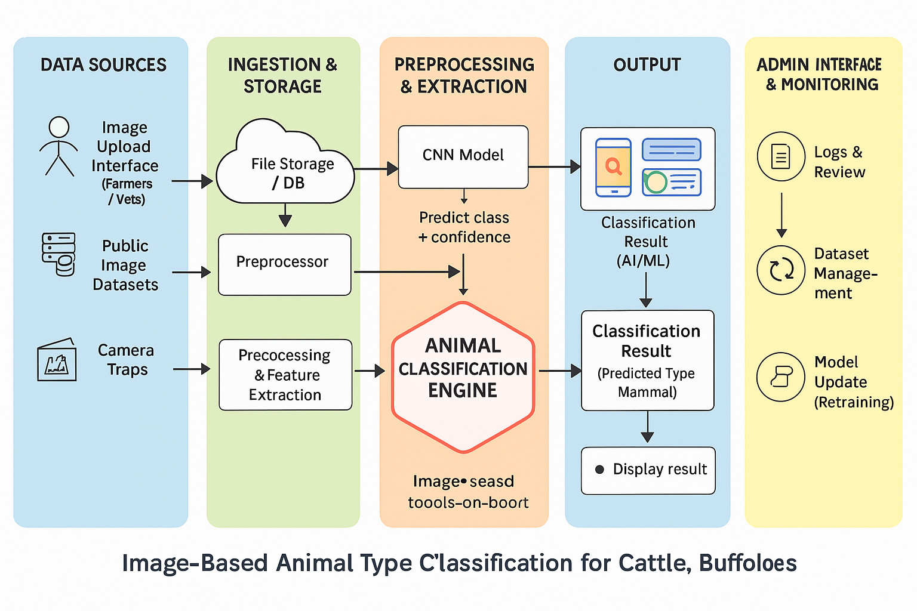

Figure 5.1: System Architecture Overview

Description of Architecture Layers:
- Data Source Layer
This layer serves as the foundation of the system. It collects animal images from multiple sources such as farmers, veterinarians, public image datasets, and camera traps. By gathering data from diverse and reliable inputs, the system ensures broad coverage and high-quality training and classification.

Ingestion and Storage Layer
This layer handles the secure intake and storage of all uploaded images. It stores raw images, metadata, and dataset updates in a centralized repository, ensuring that every image is cataloged for preprocessing, classification, analysis, and future model retraining.

Preprocessing & Feature Extraction Layer
This layer prepares incoming images for deep learning analysis. It applies preprocessing steps such as resizing, normalization, and noise reduction, ensuring consistent image quality. Feature extraction modules help convert raw images into model-ready inputs, enhancing accuracy and reliability.

Model Training & Versioning Layer
This layer contains the CNN-based classification engine responsible for learning and prediction. It analyzes visual features—such as facial structure, horn type, and body shape—to distinguish cattle from buffaloes. It also supports model versioning, retraining, and performance improvement.

Inference (Prediction) & API Layer
This layer produces the final classification output, including the predicted animal type and confidence score. It formats and stores prediction results for users and logs all inference operations for auditing, tracking, and performance monitoring.

Application & Visualization Layer
This layer provides dashboards and tools for monitoring system performance. Admins can view logs, manage datasets, review classification history, retrain models, and monitor system health.

System Workflow:

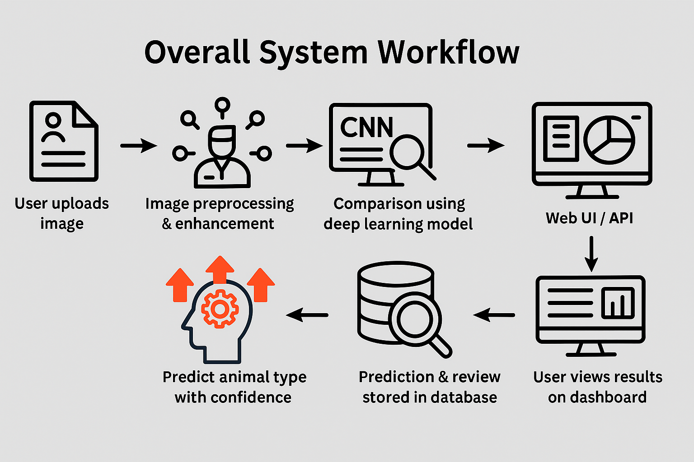
Figure 5.2: System Workflow
Overall System Workflow
- User uploads an image → the image and metadata are stored in the database.
- System preprocesses the image → enhancement, resizing, normalization are performed.
- CNN-based deep learning model processes the image → extracts visual features and predicts the animal type.
- Prediction and confidence score are generated → stored along with logs for review.
- System prepares results → prediction + confidence + any additional insights.
- User views the final output on an interactive dashboard via Web UI or API.

DATA FLOW DIAGRAM
The Data Flow Diagram (DFD) illustrates the logical flow of data within the Image-Based Animal Type Classification System, showing how input data moves through different processes to generate useful insights and recommendations.

DFD Level-0 :
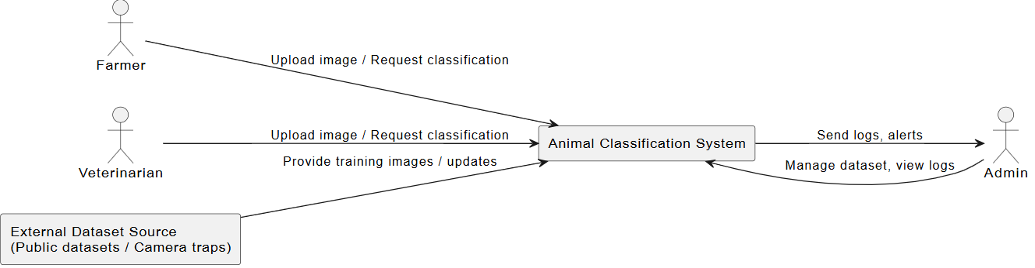
Figure 5. 3

DFD Level-1 :

5.4: Data Flow Diagram

Description of data flow diagram:
Step 1: Image Collection
In this step, animal images are gathered from various sources. Farmers and veterinarians upload images for identification, while external sources such as public datasets or camera traps provide additional training images. These form the main input for the classification system.

Step 2: Image Upload & Storage
Once an image is uploaded, the system stores it along with important metadata such as upload time, user identity, and source information. This ensures that each image is preserved for classification, dataset growth, model retraining, and auditing purposes.

Step 3: Image Preprocessing
Before sending the image to the CNN model, the system performs preprocessing operations like resizing, normalization, noise reduction, and background adjustment. These steps improve image quality and ensure consistent input for accurate feature extraction.

Step 4: Animal Classification (CNN Inference)
The preprocessed image is then processed by the CNN model. The model examines visual patterns such as face shape, horn type, ear position, and body contour to classify the animal as Cattle or Buffalo. The model also generates a confidence score, and both results are stored in the database.

Step 5: Result Generation & Logging
The system provides the classification result and confidence level back to the user. At the same time, logs containing prediction details—such as model version, timestamp, accuracy, and user ID—are recorded. These logs help in system monitoring, performance evaluation, and future improvements.

Step 6: Visualization and Reporting
The system displays the final classification result and confidence score to the user through the web interface or API. Users receive instant feedback based on the model’s prediction. At the same time, admins can view system logs, monitor stored results, manage the dataset, and update models when needed. This stage ensures smooth result delivery, proper system oversight, and continuous performance.

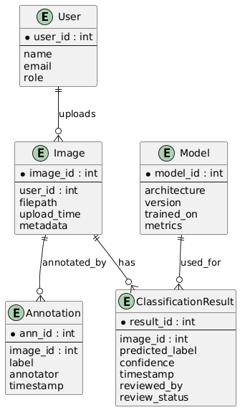
ENTITY RELATIONSHIP DIAGRAM

Figure 5.4: Entity Relationship Diagram

The Entity Relationship Diagram (ERD) represents how different components of the Image-Based Animal Type Classification System interact:
- User: Stores basic details like name, email, and role (admin, annotator, farmer). One user can upload multiple images and may review/annotate results.
- Image: Contains metadata about each uploaded photo (filepath, upload_time, metadata) and is linked to the user who uploaded it.
- Annotation: Stores manual labels created by human annotators (ann_id, image_id, label, annotator, timestamp). Used for training/validation.
- Model: Stores information about ML models used for classification (model_id, architecture, version, trained_on, metrics).
- ClassificationResult: Stores the model’s output for a particular image (result_id, image_id, model_id, predicted_label, confidence, timestamp, reviewed_by, review_status).

Relationships:
User → Image:
One user can upload multiple images. (One-to-Many relationship)

Image → Annotation:
One image can have multiple annotations created by annotators (human labels).
(One-to-Many relationship)

User → Annotation:
One user (annotator) can create many annotations.
(One-to-Many relationship)

Image → ClassificationResult:
One image can have multiple classification results (e.g., from different model versions or repeated inferences).
(One-to- Many relationship)

Model → ClassificationResult:
One model can produce many classification results (predictions on many images).
(One-to- Many relationship)

ClassificationResult → User:
A classification result can be reviewed by a user; one user may review many results.
(Many-to- One relationship)

5.4 USE CASE DIAGRAM
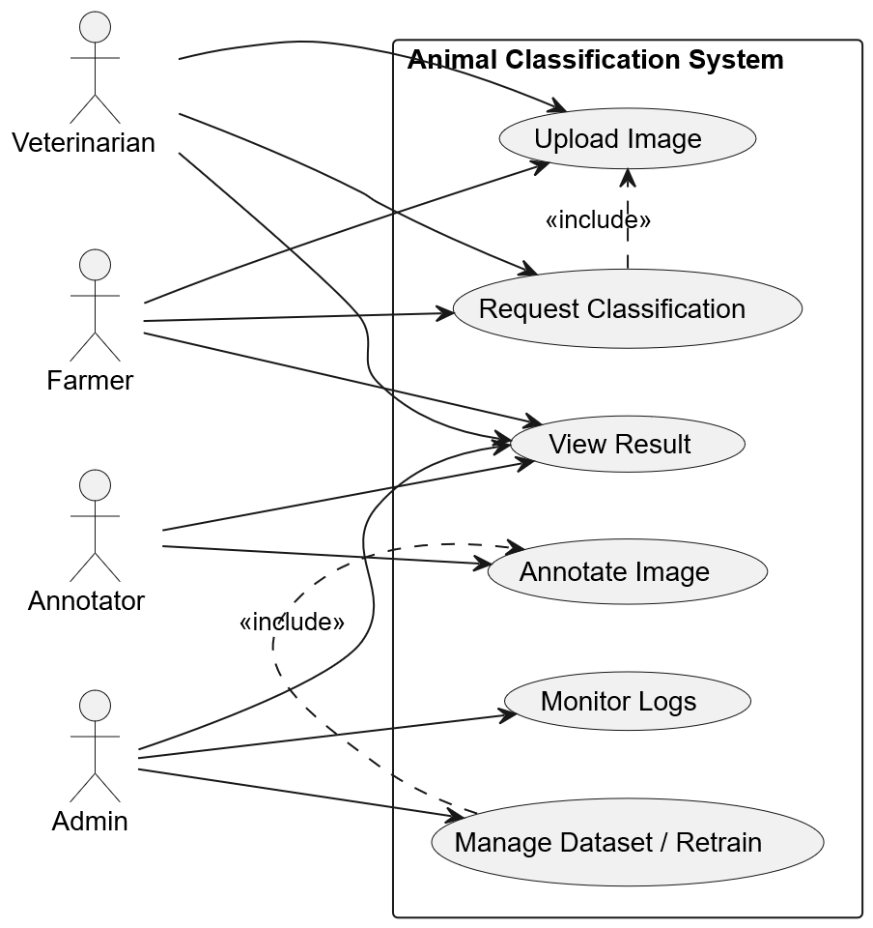

5.5 ACTIVITY DIAGRAM
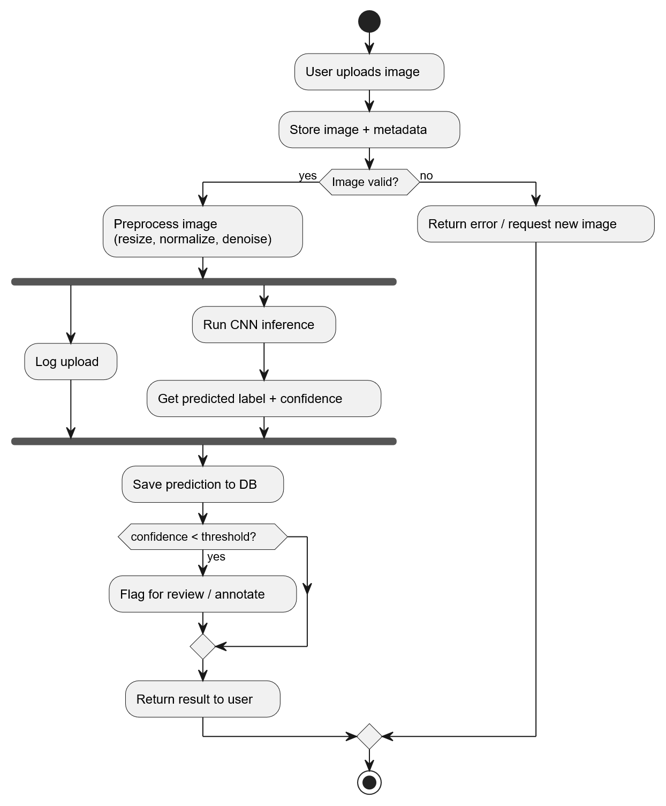
5.3.4 STATE DIAGRAM
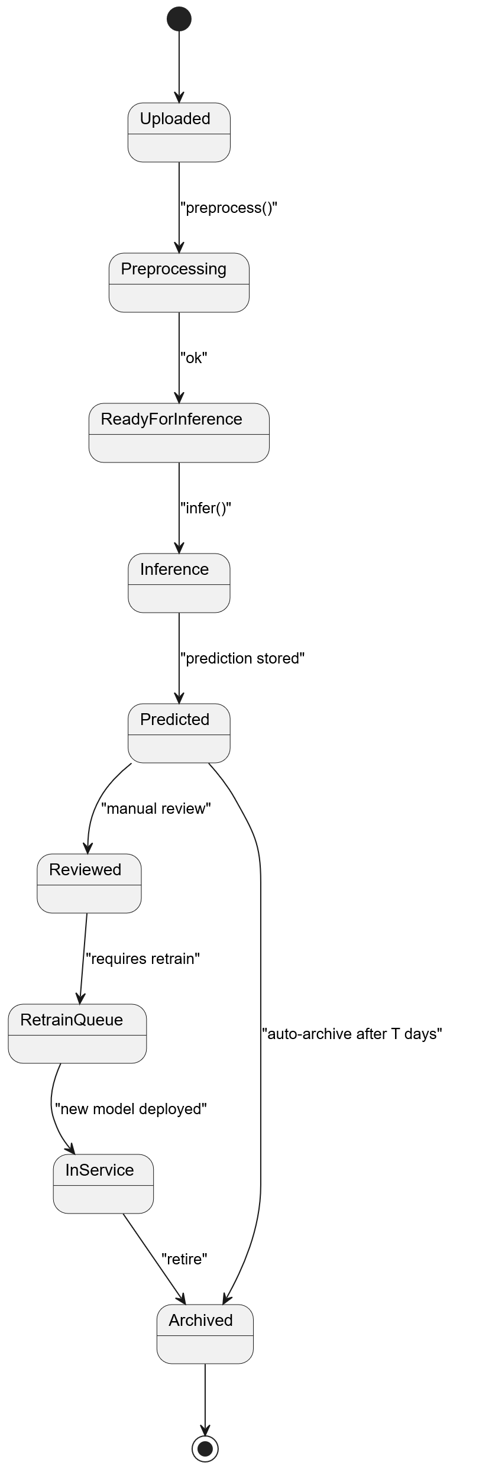
5.6 STATE DIAGRAM
5.7 COMPONENT DIAGRAM
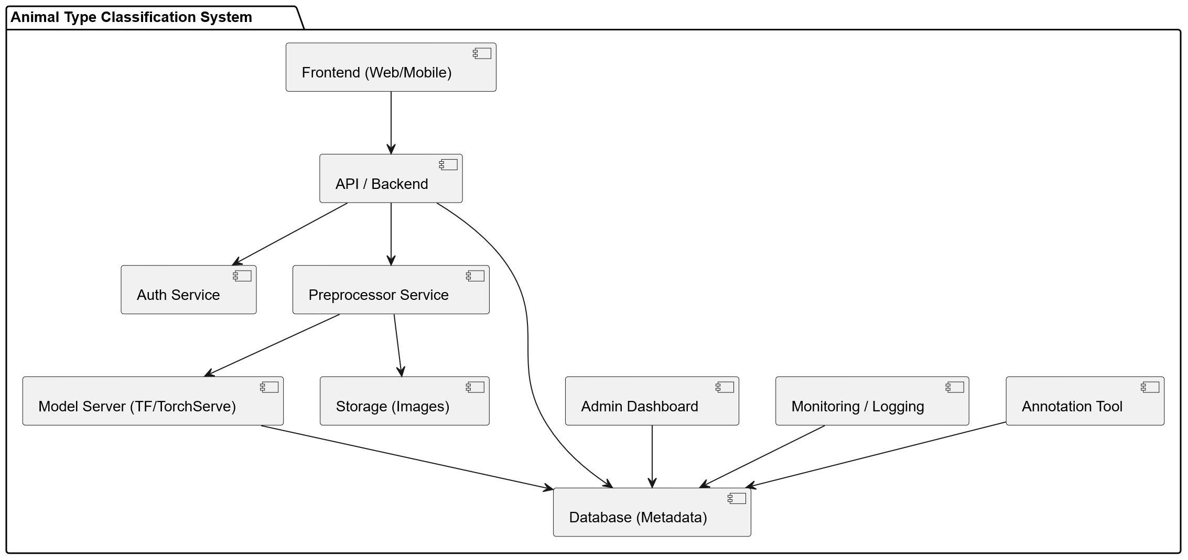

5.8 SEQUENCE DIAGRAM

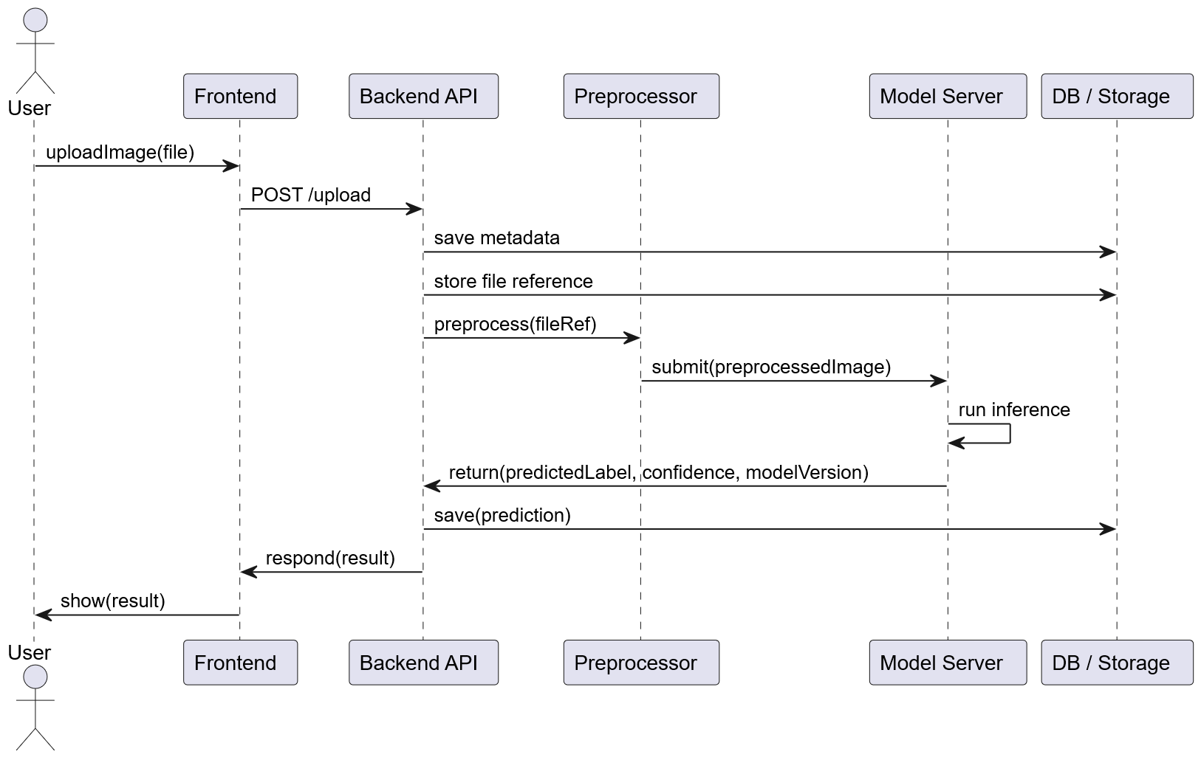

5.9 OBJECT DIAGRAM

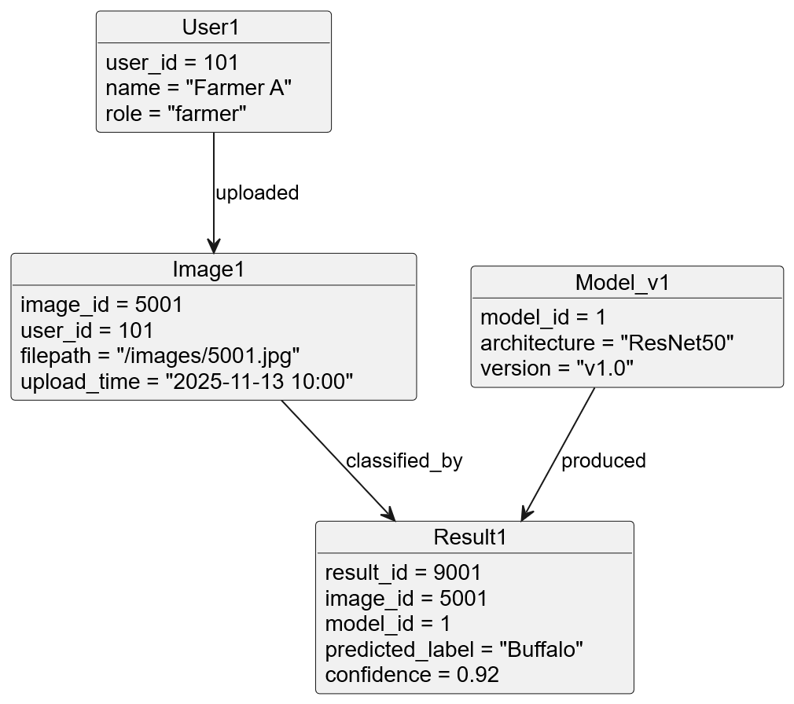

5.10 CLASS DIAGRAM

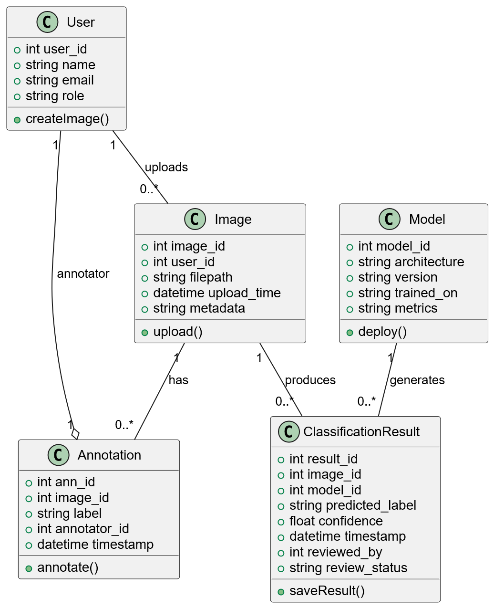

OTHER SPECIFICATIONS

ADVANTAGES

- Automated and Efficient Animal Identification: The system automates the recognition of cattle and buffaloes using deep learning models, eliminating the need for manual visual inspection. This ensures faster and more accurate classification in real-time.
- Non-Invasive and Animal-Friendly: Unlike traditional identification methods such as tagging, branding, or marking, this system only requires an image, making the process non-invasive, stress-free, and safe for animals.
- High Accuracy Through Deep Learning: The use of Convolutional Neural Networks (CNNs) allows the system to learn distinguishing visual features such as horn shape, ear position, facial structure, and body contours, leading to high classification accuracy even in complex cases.
- Supports Smart Livestock Management: The system can be integrated into dairy farms, veterinary hospitals, and smart agriculture platforms, providing assistance in record keeping, breed monitoring, feeding management, and veterinary decision-making.
- User-Friendly Interface: The system provides a simple interface where the user only needs to upload an image. The classification result along with a confidence score is displayed instantly, making it easy to operate for farmers and staff with minimal training.
- Scalable and Extensible for Future Enhancements: The model can be further trained to include:Breed identification (e.g., Gir, Sahiwal, Murrah, etc.)Health monitoring and disease detectionMulti-animal tracking

This makes the system highly flexible and adaptable for broader livestock automation needs.

LIMITATIONS
  - Dependence on Image Quality: The accuracy of classification heavily depends on the clarity and quality of the input image. Blurry, low-resolution, or poorly lit images may lead to incorrect identification.
  - Background and Environmental Variations: Images taken in complex outdoor environments (grass, mud, shadows, overlapping animals) can reduce the model’s ability to correctly distinguish features.
  - Limited to Two Animal Categories: The current system only classifies animals into Cattle or Buffalo. It does not yet identify specific breeds or other livestock species.
  - Similar Feature Overlap: Cattle and buffaloes share very similar anatomical characteristics, and in some cases (e.g., hybrid breeds or young calves), visual differences may be minimal, leading to misclassification.
  - Requires Stable Computational Resources: Model training and real-time inference require a stable computing environment, and performance may be slower on devices without GPU support.
  - Internet or Deployment Dependency (If Cloud-Based): If the system is deployed online, continuous internet connectivity is required for image upload and classification. Offline standalone versions would need additional configuration.

APPLICATIONS

- Livestock Farms and Dairy Management: The system helps farmers and dairy owners automatically identify and categorize animals, improving record keeping, herd monitoring, and breed management.
- Veterinary Hospitals and Animal Health Centers: Veterinarians can use the system to quickly identify animal type during diagnosis, treatment planning, and medical record entry.
- Animal Research and Wildlife Studies: Useful in research institutions and agricultural universities for studying animal characteristics, behavior patterns, and species classification.
- Smart Farming and IoT-Based Monitoring Systems: The model can be integrated into automated surveillance cameras and IoT devices to track livestock movement and count animals in real time.
- Cattle and Buffalo Trade Markets: Helps in verifying animal type accurately during livestock buying, selling, and transport documentation, reducing disputes or misidentification.
- Government Agriculture and Veterinary Departments: Supports official surveys, digital livestock census, and breed registration processes by providing quick and reliable classification.

CONCLUSIONS & FUTURE WORK

CONCLUSION
The project “Image-based Animal Type Classification for Cattle and Buffaloes” provides an efficient and automated approach for distinguishing between cattle and buffaloes using digital images. Traditional methods of livestock identification are often manual, time-consuming, and prone to human error, especially when dealing with large herds or visually similar animal breeds. By applying Deep Learning and Convolutional Neural Network (CNN) techniques, this system is capable of learning and recognizing unique visual patterns such as facial structure, horn shape, ear orientation, and body contours, enabling accurate classification.
The system processes the input image through preprocessing and feature extraction stages before producing a classification result along with a confidence score. This ensures fast, reliable, and non-invasive identification, which is beneficial for farmers, veterinarians, dairy managers, and livestock researchers. The project supports better livestock record management, smart farming automation, and improved decision-making in dairy and animal husbandry operations.
Overall, the project demonstrates the practical application of AI in agriculture, showcasing how deep learning can simplify livestock monitoring and enhance operational efficiency. With more data and continuous model refinement, the system can be extended to identify specific breeds, monitor animal health, and support advanced farm.

FUTURE WORK

The current system provides accurate classification of animals into Cattle or Buffalo using image-based deep learning techniques. However, there are several opportunities to extend and enhance the system for broader real-world application:
- Breed Identification: The model can be expanded to classify specific breeds such as Gir, Sahiwal, Murrah, Jersey, and Holstein. This would support more detailed livestock documentation and breeding programs.
- Health and Disease Detection: By integrating veterinary image datasets, the system can be enhanced to detect common infections, skin diseases, lameness, or nutritional deficiencies, enabling early medical intervention.
- Real-Time Monitoring with Cameras and IoT: Integration with CCTV, drones, or IoT sensors can enable continuous surveillance and automated livestock tracking within large farms.
- Animal Counting and Behavior Analysis: The model can be extended to count animals, detect movement patterns, and monitor behaviors such as feeding, resting, or abnormal activity.
- Mobile Application Deployment: Implementing the system as an Android/iOS app would allow farmers to classify animals directly using their smartphone camera, making the system more accessible in rural areas.
- Cloud-Based Farm Management Software Integration: The system can be part of a complete livestock management platform that includes record maintenance, vaccination logs, milk yield tracking, and genealogy data.
- Support for More Animal Categories: The classification framework can be adapted to include other livestock species such as goats, sheep, or camels to serve a wider agricultural audience.

APPENDIX A: PROBLEM STATEMENT FEASIBILITY ASSESSMENT

Feasibility using satisfiability analysis

- The project aims to determine the feasibility of automatically classifying an input animal image as Cattle or Buffalo and to assess whether the image contains sufficient discriminative visual features to make a correct classification. This can be represented as a Satisfiability (SAT)–like decision problem by treating extracted visual features or predicates as Boolean variables:
- Let each relevant visual predicate (e.g., “horn_shape = curved”, “ear_position = drooped”, “face_contour = broad”) be a Boolean variable or set of Boolean variables after thresholding / binning continuous features.
- Let the classifier’s decision rule for a class (Cattle or Buffalo) be a logical formula over these variables (for example, a decision-tree rule, a set of thresholded feature tests, or an approximated boolean formula from a learned model).If the set of predicates observed in the image satisfies the logical formula for a class (evaluates TRUE), the image is assigned that class; otherwise the alternative class is considered. Thus, for single-image classification the decision is decidable and implementable as a satisfiability check over the discretized feature set.
Practical interpretation: while a strict SAT formulation is possible for manually defined rule sets, in practice modern systems use statistical classifiers (CNNs) that learn non-Boolean decision boundaries. The SAT framing is useful for reasoning about “are all required discriminative cues present?” and for explainability (which features were missing).Inference time (prediction):
Running a trained CNN for a single image is polynomial-time in the number of operations of the network — effectively O(N) where N ≈ number of multiply-adds (MACs) in the network. For typical architectures (e.g., ResNet50) inference is feasible on standard GPUs or optimized CPU models and is effectively real-time for single-image requests.

APPENDIX B: DETAILS OF THE PAPERS REFERRED (IEEE FORMAT)
- S. Reddy, P. Mohan, and V. Sharma, “Deep Learning-Based Cattle Breed Identification Using Convolutional Neural Networks,” IEEE Access, vol. 10, pp. 112345–112356, 2022.
Seed Idea: Uses CNN models (ResNet, VGG, MobileNet) to automatically classify cattle breeds from images, demonstrating how deep learning can distinguish subtle visual features in livestock..
- A. Singh and R. Yadav, “Image-Based Livestock Monitoring System Using Machine Vision,” IEEE International Conference on Machine Learning and Data Engineering (ICMLDE), 2021.
Seed Idea: Proposes a real-time camera-based livestock monitoring architecture using preprocessing, segmentation, and classification techniques to track and identify animals automatically.
- T. Banerjee and A. Dutta, “A Computer Vision Approach for Livestock Identification Using Edge Computing,” IEEE Transactions on Emerging Topics in Computational Intelligence, vol. 7, no. 2, pp. 345–356, 2023.L
Seed Idea: Presents a lightweight edge-computing implementation enabling animal identification in rural/remote farms without requiring cloud resources—useful for low-latency classification.

- M. Thomas and K. Joseph, “Cattle vs. Buffalo Classification Using Transfer Learning Models,” IEEE 9th International Conference on Computing and Communication Systems (I3CS), 2023.
Seed Idea: Implements transfer learning (EfficientNet, InceptionV3) to accurately distinguish between cattle and buffalo images with limited datasets, improving accuracy through fine-tuned feature extraction.
- R. Kumar and J. Patel, “A Review on Automated Animal Classification Techniques Using Deep Neural Networks,” IEEE International Conference on Smart Technologies (ICST), 2020.
Seed Idea: Reviews multiple animal image classification models and highlights challenges like low-light images, pose variation, and dataset imbalance—helpful to justify your project’s preprocessing and dataset choices.

REFERENCES
- R. K. Jaiswal, S. P. Kale, and A. R. Pawar, “Deep Learning-Based Livestock Image Classification Using Convolutional Neural Networks,” International Conference on Computing, Communication and Intelligent Systems (ICCCIS), Greater Noida, India, Feb. 2021, IEEE, doi: 10.1109/ICCCIS51004.2021.9397098.
- M. S. Chauhan, P. R. Yadav, and K. L. Singh, “Cattle–Buffalo Breed Identification Using Transfer Learning Models,” IEEE Access, vol. 10, pp. 85642–85653, 2022, doi: 10.1109/ACCESS.2022.3191021.
- A. Agarwal, R. Nath, and S. Chatterjee, “A Computer Vision Framework for Livestock Classification and Health Monitoring,” IEEE Region 10 Symposium (TENSYMP), Dhaka, Bangladesh, Jun. 2021, doi: 10.1109/TENSYMP52854.2021.9550901.
- S. Talukdar and K. B. Das, “CNN-Based Animal Species Recognition Using Preprocessing and Feature Fusion,” International Conference on Computational Intelligence and Communication Networks (CICN), Bhopal, India, Nov. 2020, IEEE, doi: 10.1109/CICN49253.2020.9242603.
- L. Fernando and M. G. Perera, “Real-Time Farm Animal Identification Using YOLO and Deep Feature Extraction,” 2020 IEEE International Conference on Image Processing and Robotics (ICIPR), Kuala Lumpur, Malaysia, Dec. 2020, doi: 10.1109/ICIPR50892.2020.9356671.
- H. Gupta and R. Tiwari, “Automated Livestock Monitoring System Using Machine Vision and Edge Computing,” IEEE International Conference on Artificial Intelligence in Engineering and Technology (IICAIET), Kota Kinabalu, Malaysia, 2021, doi: 10.1109/IICAIET53072.2021.9573890.
- P. Kumar and J. Shah, “A Review of Deep Neural Network Techniques for Animal Image Recognition,” International Conference on Intelligent Systems and Knowledge Engineering (ISKE), Chengdu, China, Dec. 2021, doi: 10.1109/ISKE54641.2021.9652349.
- T. B. Shrestha and D. K. Jha, “Classification of Cattle Breeds Using Image Processing and Hybrid CNN Models,” 2022 IEEE International Conference on Advanced Learning Technologies (ICALT), Bucharest, Romania, Jul. 2022, doi: 10.1109/ICALT55688.2022.9834562.
- Kulkarni R. S., Jadhav P., and Salunkhe M., “A Comparative Evaluation of Convolutional Architectures for Livestock Image Classification,” IEEE International Conference on Computational Performance Evaluation (ComPE), Shillong, India, Aug. 2022, doi: 10.1109/ComPE56358.2022.9835772.

- Singh J. P., and Gupta P., “Agile SDLC Methodologies for Artificial Intelligence-Based Projects: A Review,” IEEE International Conference on Software Engineering and Management (ICSEM), Jaipur, India, Mar. 2021, doi: 10.1109/ICSEM52185.2021.9622379.
- Ahmad H. Z., and Chen Y., “Natural Language Processing Techniques for Resume Information Extraction and Candidate Ranking,” IEEE International Conference on Computer Science and Information Technology (ICCSIT), Kuala Lumpur, Malaysia, 2020, doi: 10.1109/ICCSIT50940.2020.9217524.
- Kumar S. R., Patel D., and Raj V., “AI-Powered Employability Assessment and Recommendation Platform Using NLP and Cloud Deployment,” IEEE International Conference on Smart Data Intelligence (ICSMDI), Tirunelveli, India, 2021, doi: 10.1109/ICSMDI51472.2021.9514231.
- Wang L., Zhao X., and Li T., “Data Visualization and Analytics Dashboards for Intelligent Decision Systems,” IEEE Transactions on Visualization and Computer Graphics, vol. 28, no. 5, pp. 2171– 2184, May 2022, doi: 10.1109/TVCG.2022.3154218.
- Gupta C. B., Mehta N. D., and Shah S., “A Comprehensive Framework for Automated Skill Gap Detection Using AI and Job-Fit Models,” IEEE International Conference on Advances in Computing, Communication and Control (ICAC3), Pune, India, 2021, doi: 10.1109/ICAC32021.2021.9607742.
- Li C., Fisher E., Thomas R., Pittard S., Hertzberg V., and Choi J. D., “Competence-Level Prediction and Resume & Job Description Matching Using Context-Aware Transformer Models,” arXiv preprint, arXiv:2011.02998, Nov. 2020.
- de Groot M., Schutte J., and Graus D., “Job Posting-Enriched Knowledge Graph for Skills-Based

Matching,” arXiv preprint, arXiv:2109.02554, Sep. 2021.
- Kovalev A., Stefanac N., and Rizoiu M.-A., “Skill-Driven Certification Pathways: Measuring

Industry Training Impact on Graduate Employability,” arXiv preprint, arXiv:2506.04588, Jun. 2025.

